Experiment 4: Voltage-to-Frequency and Frequency-to-Voltage Conversion using LM33

Name: Mansi Uniyal

Roll no.: 19EE10039

Date: 2 February 2021

* Objective:   
  Study the performance of Voltage-to-Frequency and Frequency-to-Voltage converters using LM331.
* Theory: LM331:

It is a precision voltage to frequency converter having the following important features:

1. Operates on single +15 V power supply.
2. Frequency range: 1 Hz to 100 kHz.

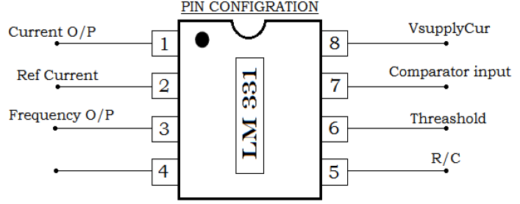

|  |  |  |  |
| --- | --- | --- | --- |
| **Pin name** | **Pin no.** | **In/Out** | **Description** |
| IOUT | 1 | O | Current output |
| IREF | 2 | I | Reference current |
| FOUT | 3 | O | Frequency output: open-collector output and requires a pullup resistor |
| GND | 4 | Ground | Ground |
| RC | 5 | I | R-C filter input |
| THRESH | 6 | I | Threshold input |
| COMPIN | 7 | I | Comparator input |
| VS | 8 | Supply | Supply voltage |

* Voltage-to-Frequency Converter:

Connect the circuit. The frequency output is given by:

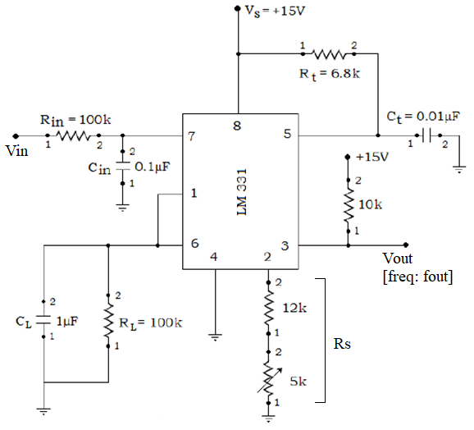

* Simulation Assignment:

1. Compute numerically the value of Vin needed to generate fout of 2.5 kHz for Rt = 6.8 kΩ, Ct = 0.01 µF, Rs = 17 kΩ and RL = 100 kΩ.

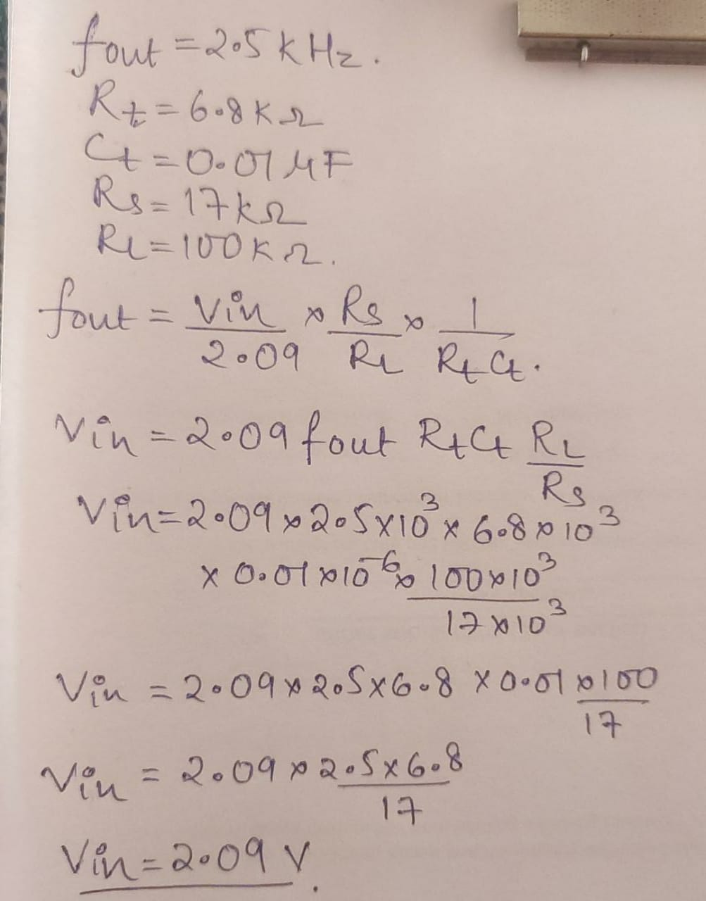

1. Draw neatly the Voltage-to-Frequency converter circuit diagram in LTSpice. All the components should be chosen as ideal. Attach the screen-shot of the schematic after entering your Name and Roll No as a text on it.
2. Construct the circuit, and simulate using the computed value of Vin. In the simulated waveform, measure frequency fout of the output signal Vout, and attach the screenshot of the plot.

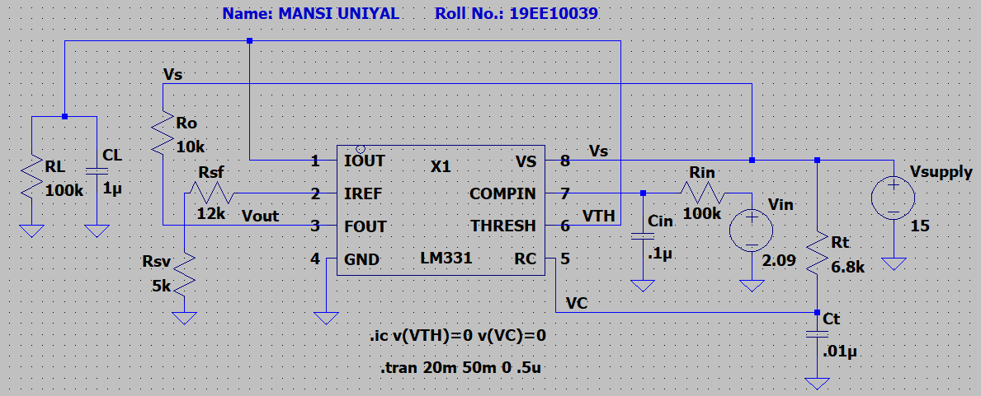

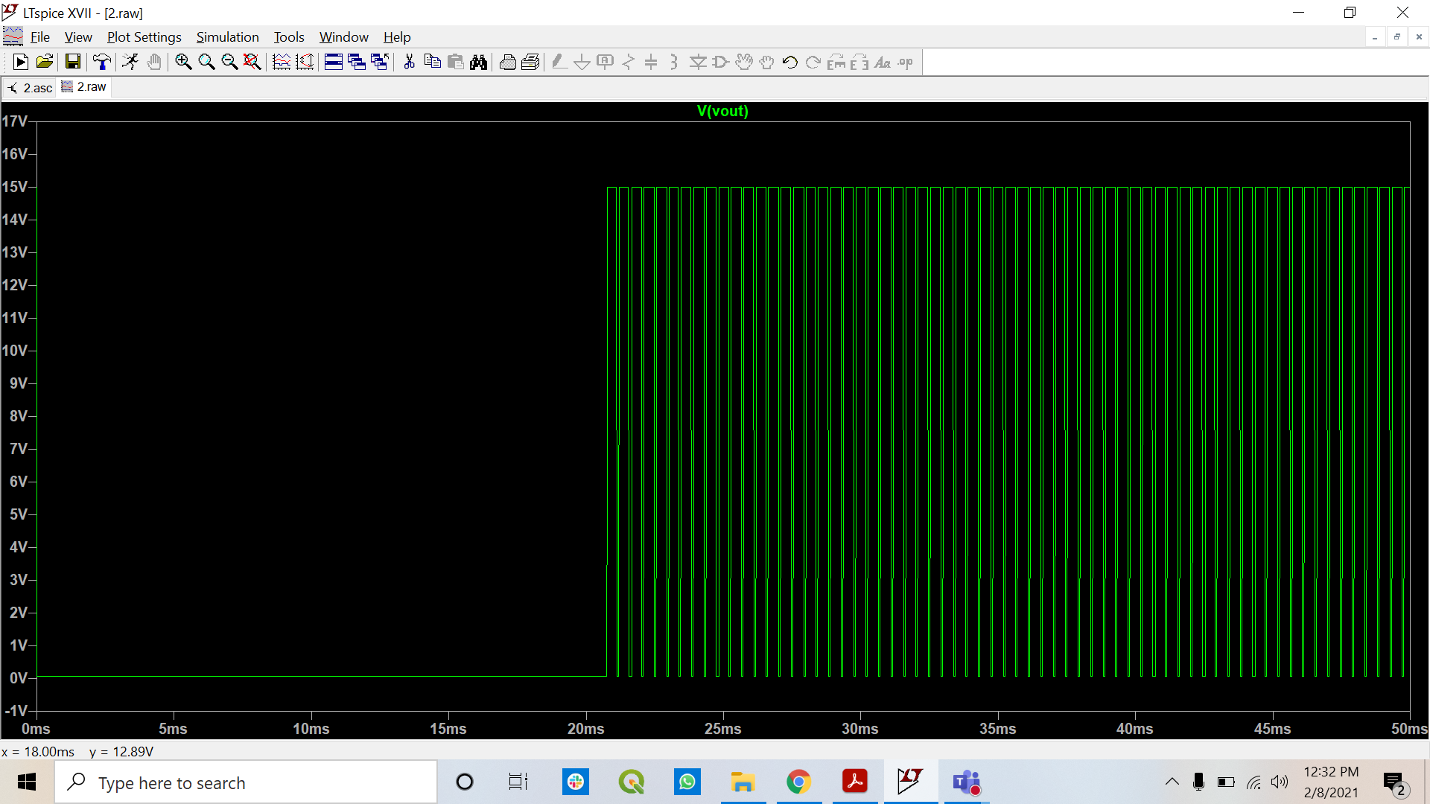

|  |  |  |
| --- | --- | --- |
| Vin (V) | Theoretical (kHz) | Experimental (kHz) |
| 2.09 | 2.5 | 2.234 |

1. Vary the value of Vin in the range of +1 V to +4 V with a step of 0.2 V, and attach the screenshot of the Vout. Plot the frequency fout versus Vin values in a curve.

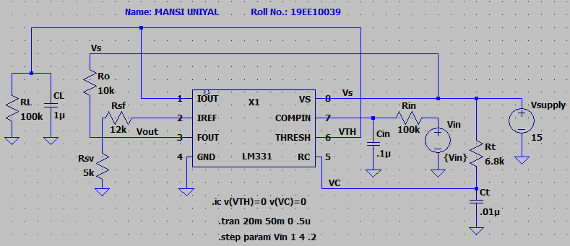

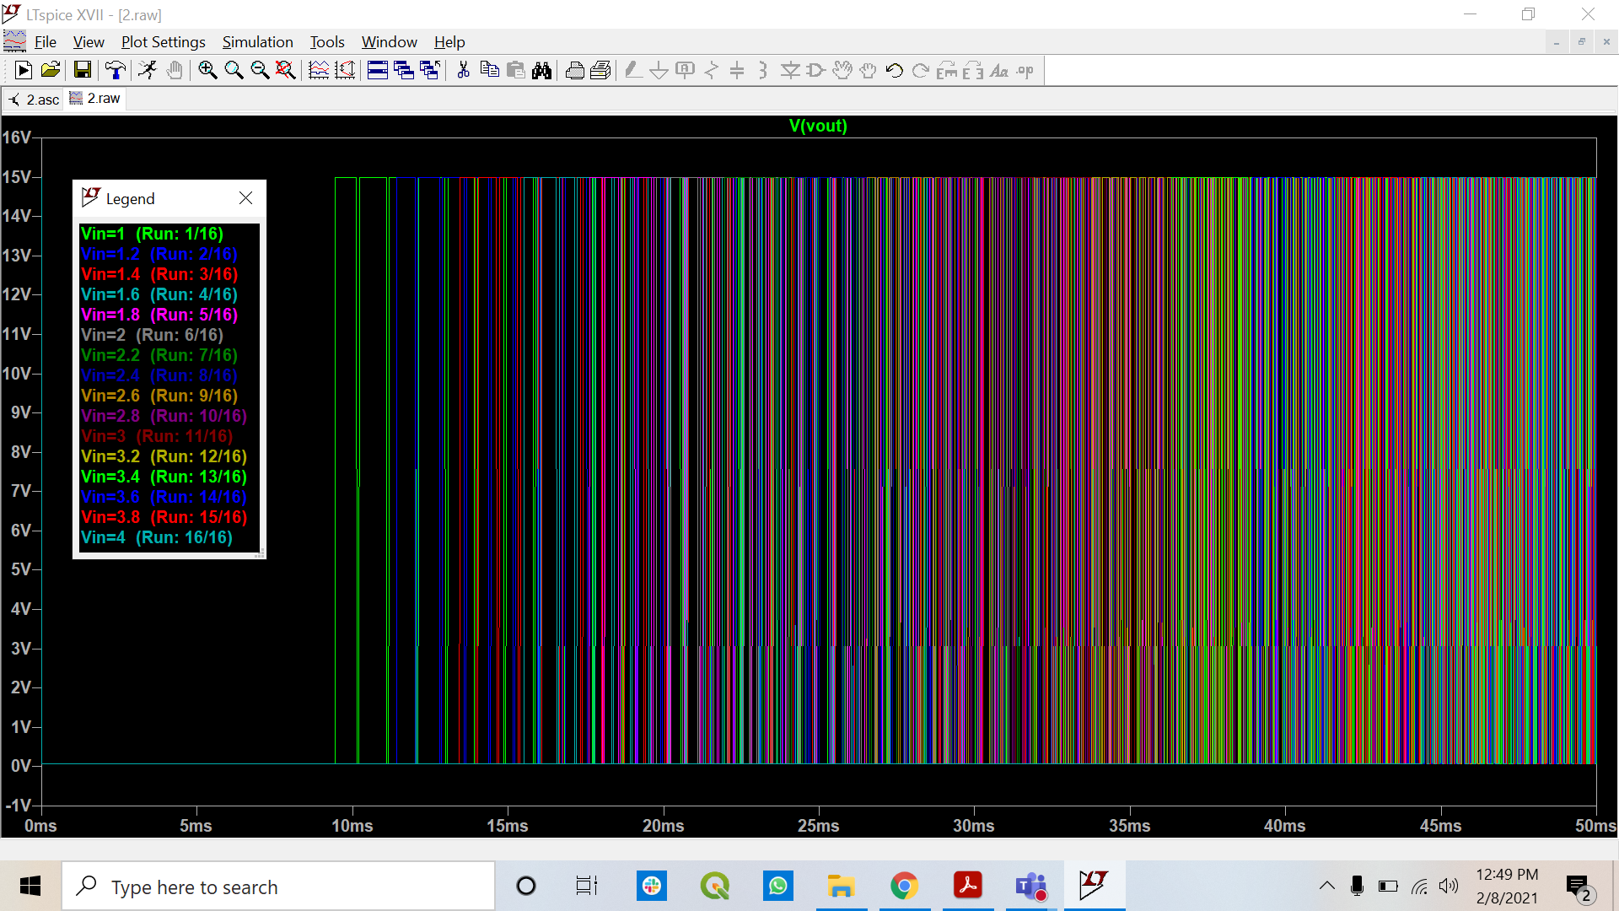

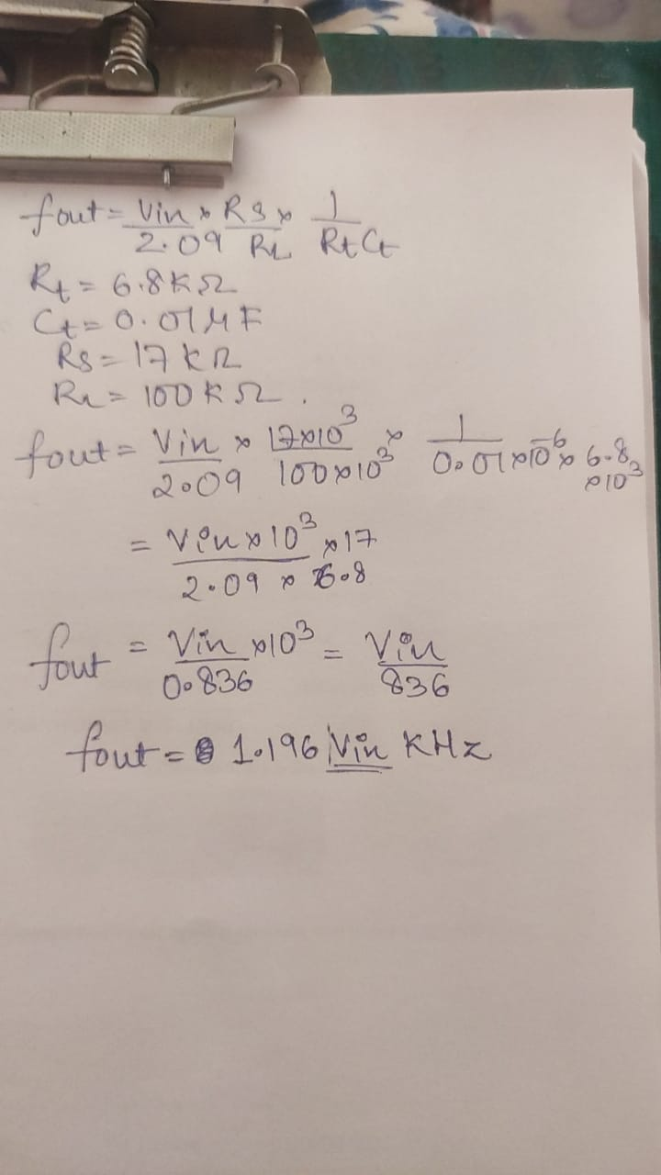with the increase in Vin, the fout increases.

|  |  |  |  |
| --- | --- | --- | --- |
|  | fout | | |
| Vin (V) | Theoretical (kHz) | Experimental (kHz) | Error (%) |
| 1 | 1.196 | 1.058 | 11.53846154 |
| 1.2 | 1.44 | 1.266 | 12.08333333 |
| 1.4 | 1.67 | 1.476 | 11.61676647 |
| 1.6 | 1.91 | 1.688 | 11.62303665 |
| 1.8 | 2.15 | 1.895 | 11.86046512 |
| 2 | 2.39 | 2.108 | 11.79916318 |
| 2.2 | 2.63 | 2.318 | 11.86311787 |
| 2.4 | 2.87 | 2.528 | 11.91637631 |
| 2.6 | 3.11 | 2.739 | 11.92926045 |
| 2.8 | 3.35 | 2.952 | 11.88059701 |
| 3 | 3.59 | 3.162 | 11.92200557 |
| 3.2 | 3.83 | 3.37 | 12.01044386 |
| 3.4 | 4.07 | 3.579 | 12.06388206 |
| 3.6 | 4.31 | 3.790 | 12.0649652 |
| 3.8 | 4.54 | 4.00 | 11.89427313 |
| 4 | 4.78 | 4.079 | 14.66527197 |

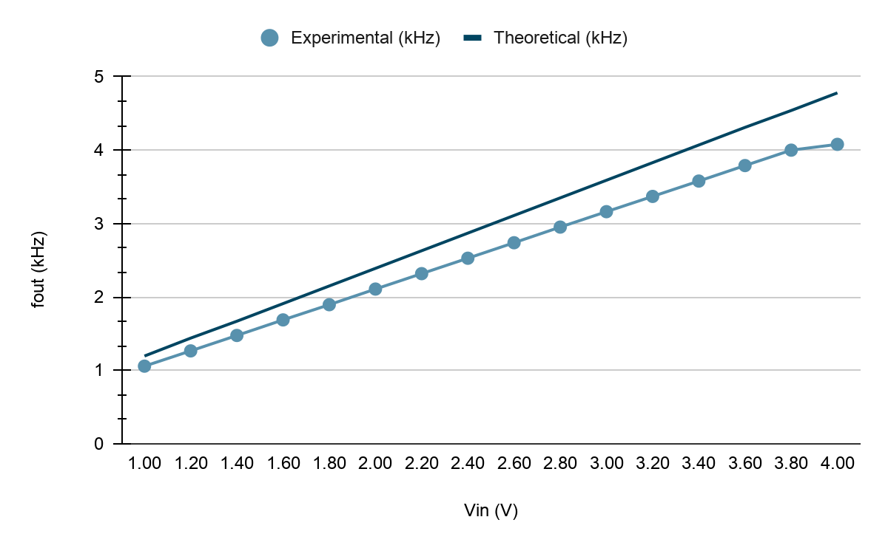

* Points to be discussed in brief:

1. From the simulated fout obtained in step (d), plot the non-linearity (in %) versus Vin values (+1 V to +4 V) in a curve.

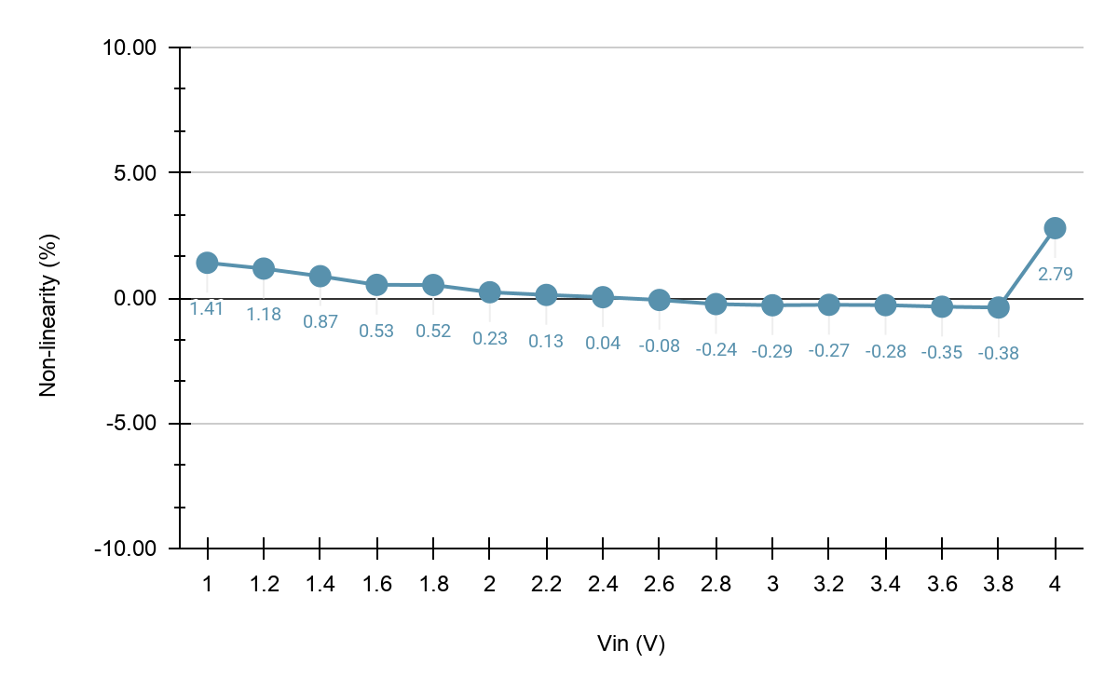

1. Compute fout for the Vin range of +1 V to +4 V with a step of 0.2 V using given expression in (1). Plot the error between simulated fout (obtained in step (d)) and computed fout versus Vin values in a curve.

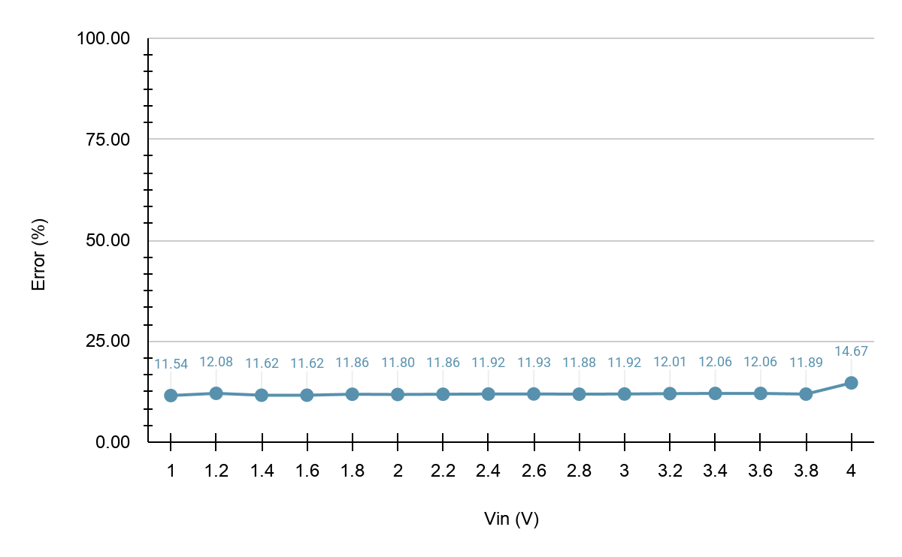

* Frequency-to-Voltage Converter:

Connect the circuit as shown in Fig. 4. The voltage output is given by:

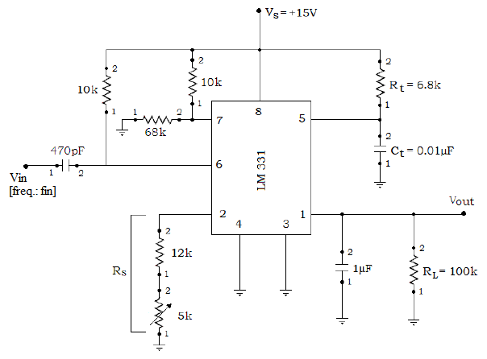

* Simulation Assignment:

1. Compute numerically the value of Vout when input signal frequency fin is 2.5 kHz for Rt = 6.8 kΩ, Ct = 0.01 µF, Rs = 17 kΩ and RL = 100 kΩ.

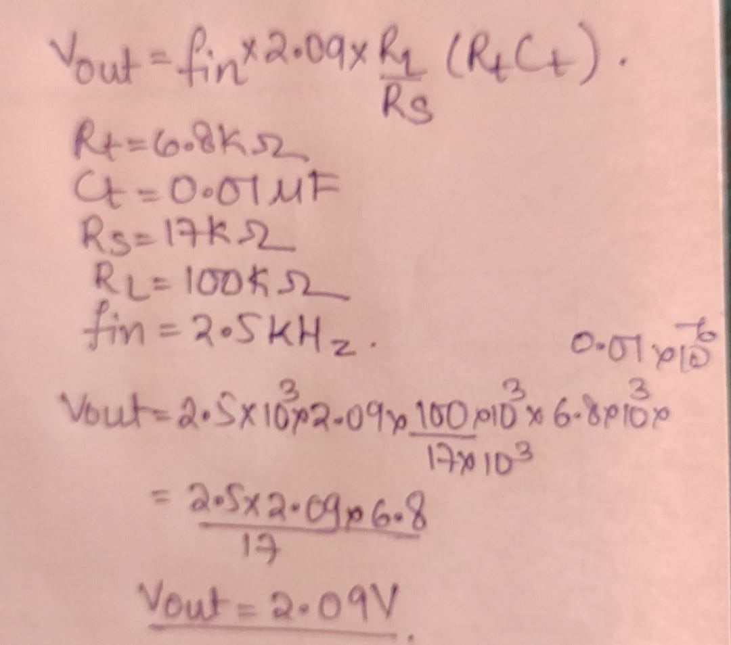

1. Draw neatly the Frequency-to-Voltage converter circuit diagram in LTSpice. All the components should be chosen as ideal. Attach the screen-shot of the schematic after entering your Name and Roll No as a text on it.
2. Construct the circuit, and simulate for pulse input signal Vin with fin = 2.5 kHz, Vhigh = 15 V and Vlow = 0 V. In the simulated waveform, measure output Vout and attach the screenshot of the plot.

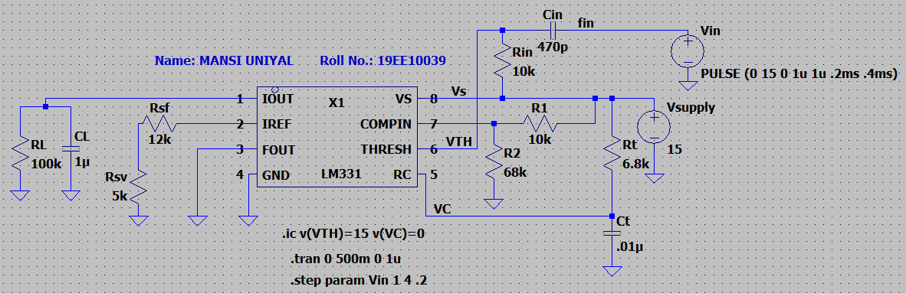

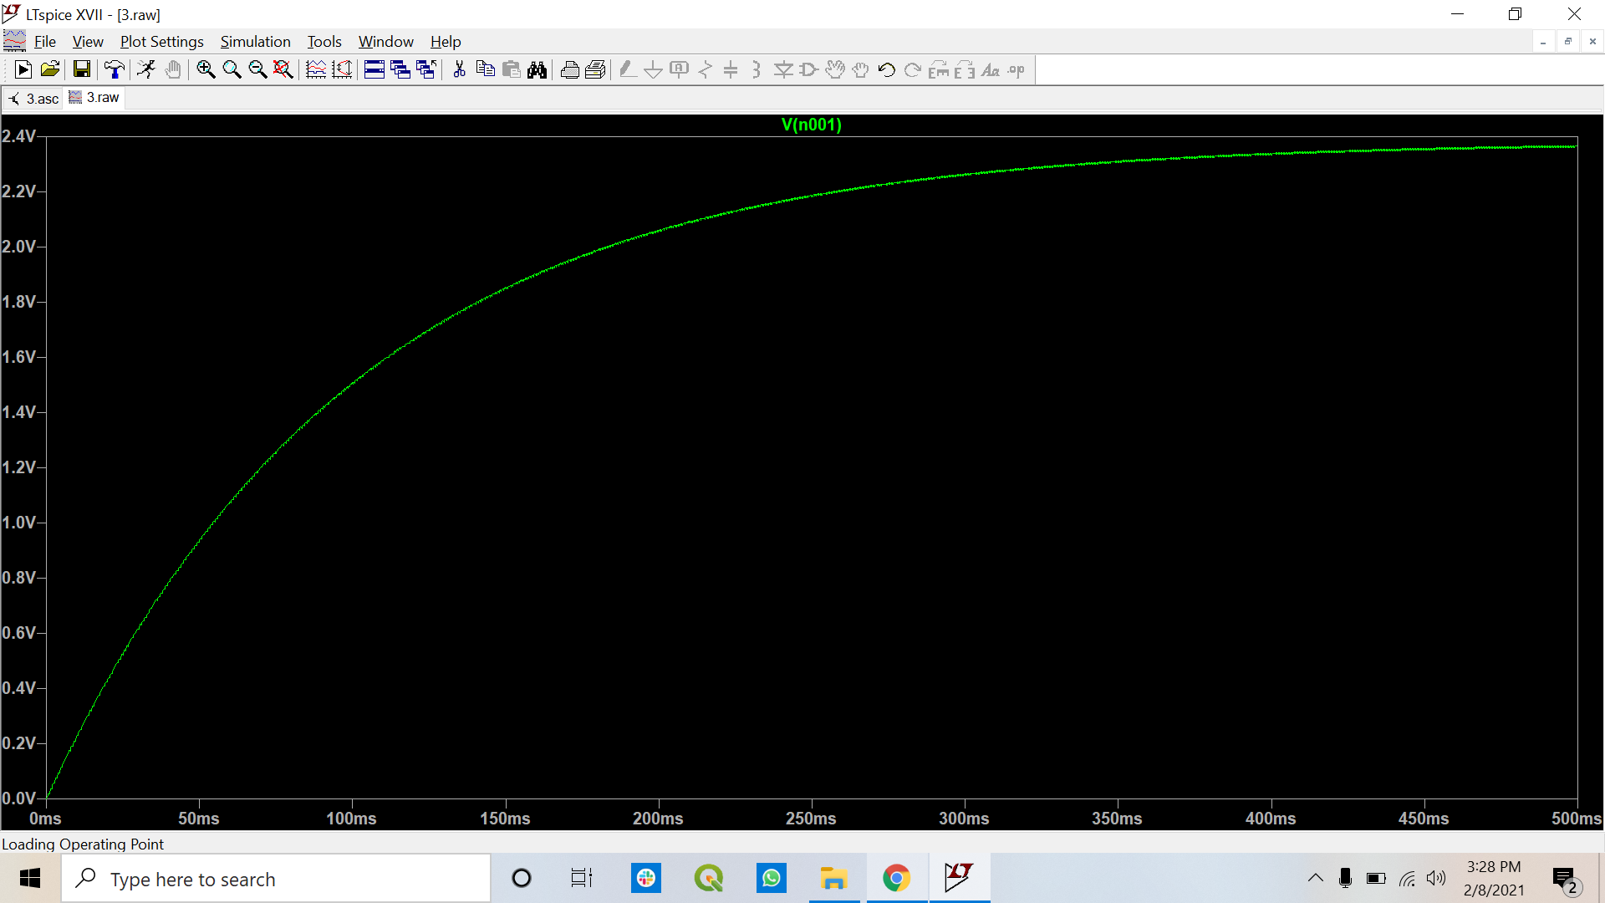

|  |  |  |
| --- | --- | --- |
|  | Vout | |
| fin (kHz) | Theoretical (V) | Experimental (V) |
| 2.5 | 2.09 | 2.36 |

1. Only vary the value of fin in the range of 1 kHz to 4 kHz with a step of 0.2 kHz, and attach the screenshot of the Vout. Plot the Vout versus fin values in a curve.

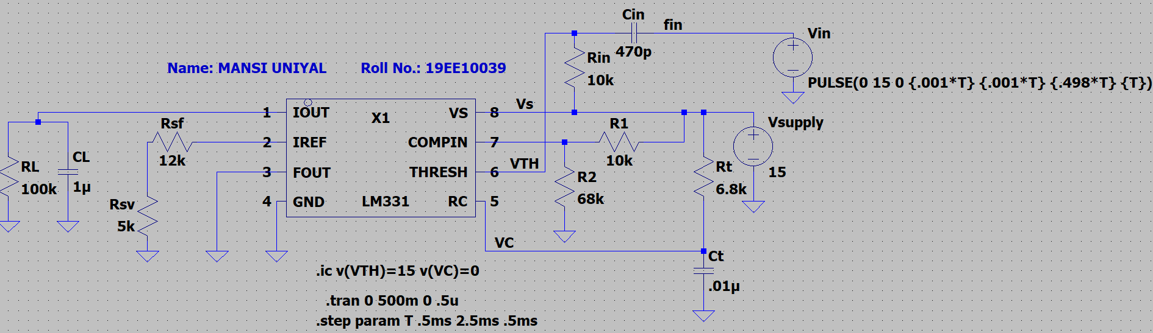

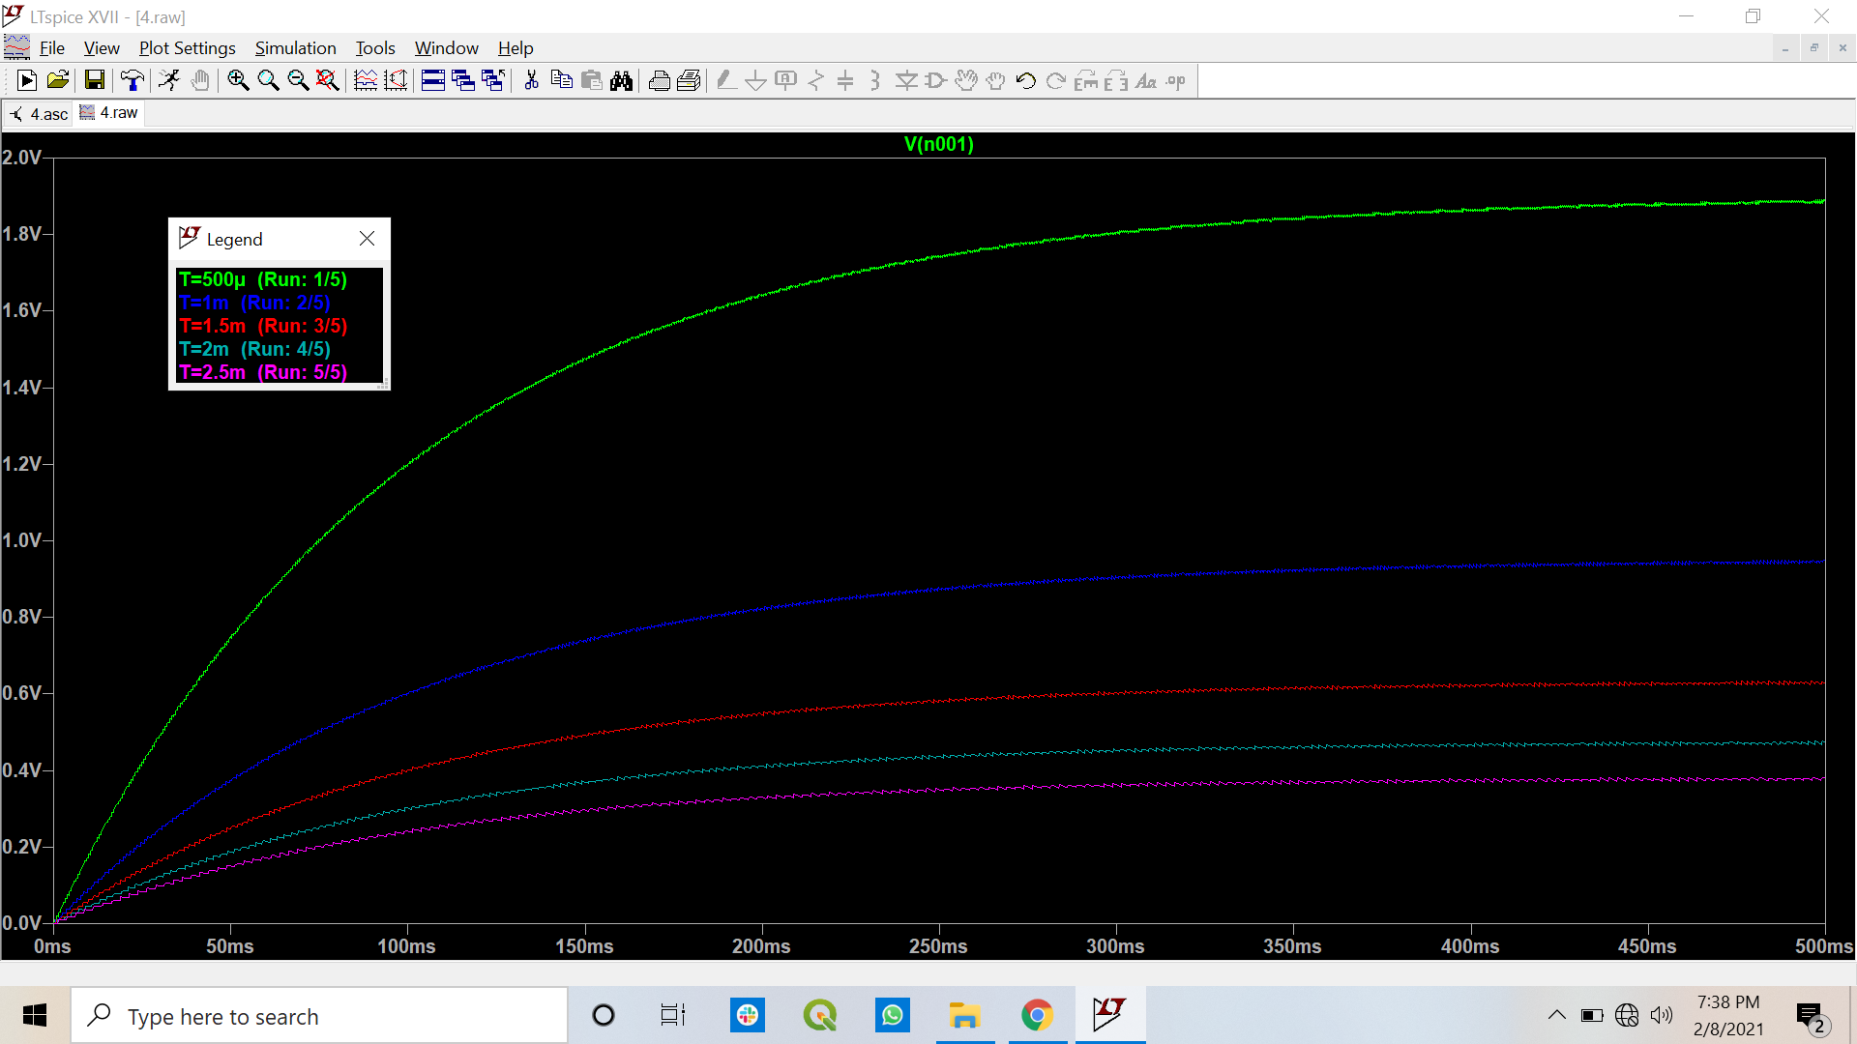

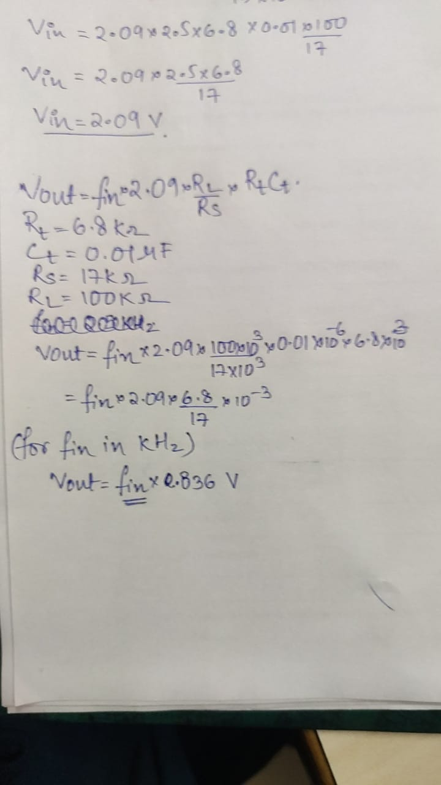with the increase in fin, the Vout increases.

|  |  |  |  |  |
| --- | --- | --- | --- | --- |
|  |  | Vout | | |
| T (ms) | fin (kHz) | Theoretical (mV) | Experimental (mV) | Error (%) |
| 0.5 | 2 | 1672 | 1887.55 | 12.89174641 |
| 1 | 1 | 836 | 945.84 | 13.13875598 |
| 1.5 | 0.667 | 557.612 | 626.58 | 12.36845692 |
| 2 | 0.5 | 418 | 472.17 | 12.95933014 |
| 2.5 | 0.4 | 334.4 | 378.01 | 13.04126794 |

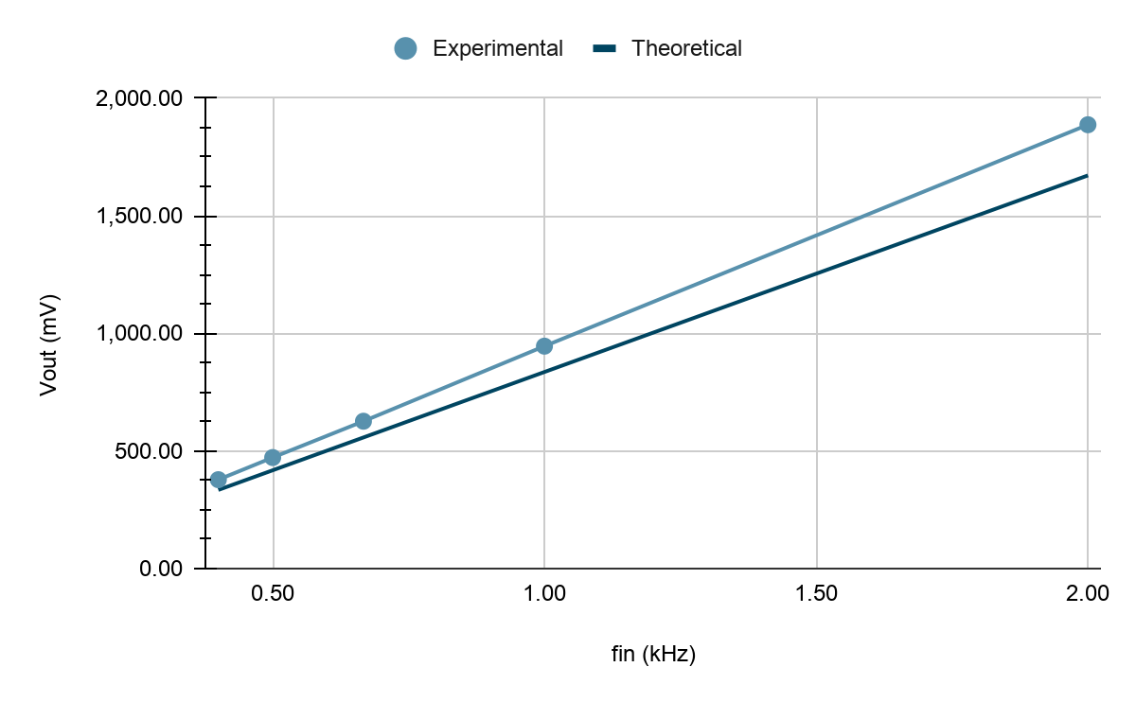

* Points to be discussed in brief:

1. From the simulated Vout obtained in step (d), plot the non-linearity (in %) versus fin values (1 kHz to 4 kHz) in a curve.

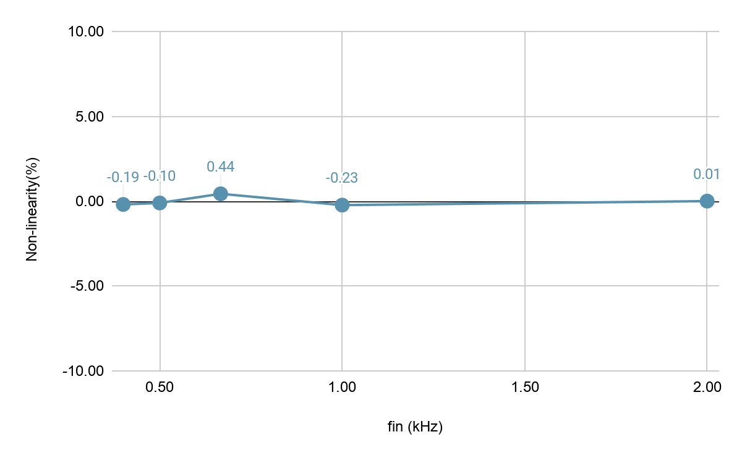

1. Compute Vout for the fin range of 1 kHz to 4 kHz with a step of 0.2 kHz using given expression in (2). Plot the error between simulated Vout (obtained in step (d)) and computed Vout versus fin values in a curve.

